You’re Invited!

“YOUR COMMUNITY PARTNERS”

Proudly offers the following FREE DBPR

“Condominium and HOA Director Certification Courses”

We’re pleased to present our Guest Speaker:

Kevin T. Wells, Esq.
Law Offices of Wells|Olah, P.A.

TPC Prestancia
4409 Tournament Players Club Drive
Sarasota, FL 34238
October 11, 2018
Condo Course
8:30am- 10:30am

October 25, 2018
HOA Course
8:30am -10:30am
April 10, 2019
Condo Course
8:30am- 10:30am

April 25, 2019
HOA Course
8:30am -10:30am

January 24, 2019
Condo Course
8:30am- 10:30am

January 31, 2019
HOA Course
8:30am -10:30am

December 6, 2018
Condo Course
8:30am- 10:30am

December 18, 2018
HOA Course
8:30am -10:30am

Please arrive 15-30 minutes early for registration.

Please RSVP to boardcertclass@gmail.com
or 941.366.9191 by 12:00 noon the Monday before the event as space is limited.
Although there is no cost to you personally, the sponsors are charged per attendee. If you find you are unable to attend after making a reservation, please let us know as soon as possible.
Gourmet Breakfast Buffet included in free seminar.

Name: ________________________________________________ Phone: ______________________________________

Company/Association: _________________________________ Email: ______________________________________

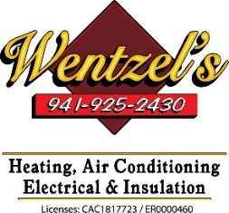
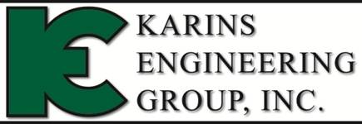
Proudly Sponsored By:

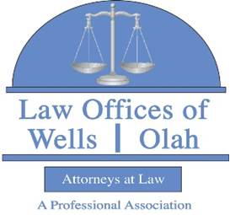
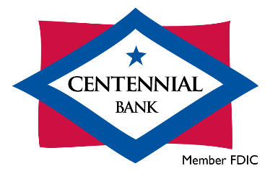
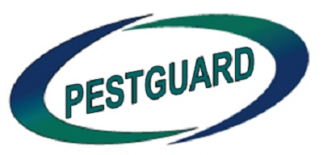
|

