You’re Invited!

“YOUR COMMUNITY PARTNERS”

Proudly offers the following FREE DBPR

“Condominium and HOA Director Certification Courses”

We’re pleased to present our Guest Speaker:

Kevin T. Wells, Esq.
Law Offices of Wells|Olah, P.A.

The Venice Golf and Country Club
250 Venice Golf Club Drive
Venice, FL 34292
February 14, 2019
Condo Course
8:30am- 10:30am

February 28, 2019
HOA Course
8:30am -10:30am

November 14, 2018
Condo Course
8:30am- 10:30am

November 29, 2018
HOA Course
8:30am -10:30am

Please arrive 15-30 minutes early for registration.

Please RSVP to boardcertclass@gmail.com
or 941.366.9191 by 12:00 noon the Monday before the event as space is limited.
Although there is no cost to you personally, the sponsors are charged per attendee. If you find you are unable to attend after making a reservation, please let us know as soon as possible.
Gourmet Breakfast Buffet included in free seminar.

Name: ________________________________________________ Phone: ______________________________________

Company/Association: _________________________________ Email: ______________________________________

Proudly Sponsored By:

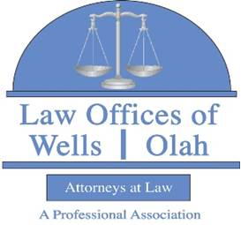
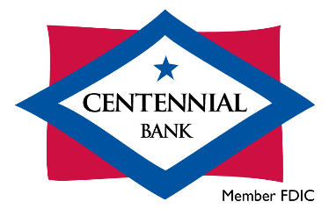
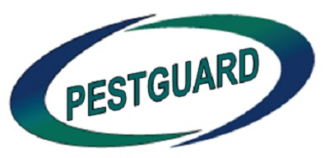
|

