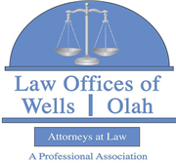 | 2019 COMMUNITY ASSOCIATION LEGAL UPDATE – 2 CEUs (LU) – DBPR Course Number 9629117  Presented by Kevin Wells - The Law Offices of Wells | Olah, P.A. | 2:30pm - 4:30pm
Get updated on the most recent legislative changes and discuss the statutory changes made by Florida Legislature and how they directly affect managers and their communities, such as official records, fining, websites, board meetings, elections, MRTA, amendments, director term limits, electronic vehicles charging stations, delinquent assessment collections, director conflicts of interests, etc.

Copy & paste this link in to your browser for registration.

www.bradentoncondoexpo.com/seminars.aspx

