2018 Condominium Board Certification  Course  Tuesday, November 13th, 2018 9am-1130am  *Registration Begins at 8:30am  Hot Breakfast Buffet will be available  Kimal Event Center  11184 Hughey Kimal Dr. Venice, FL 34292  (Please use entrance off of E. Venice Ave)  If you are planning to serve on your condo association board, you probably know that you will need to comply with Florida’s certification requirements within 90 days of being elected or appointed to your board but were you aware that you can take the course up to one year in advance?  This Condominium Association Board Member course is tailored specifically to certify condo board members. Your participation will satisfy the statutory requirement so that you are eligible to serve on your condominium association board.  Some of the topics we will cover include:  - Defining your fiduciary duty  - Analyzing association operations  - Preparing budgets & funding reserves  - Understanding financial reporting requirements  - Assessing insurance needs  If you get lost on the way to the Kimal Center  please call @ 941-932-0172 |  | Presented By:  Kevin T. Wells, Esq.  Provider #: PVD-286  Course: Florida Condominium Director DBPR Certification**  **Condominium Board Members Only
 |  | Your Sponsors
 |  | 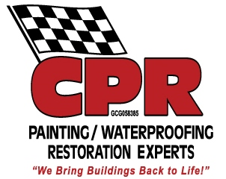
Pre-Registration Required Limited Seating
Please Email Amy at
boardcertclass@gmail.com
Your email address will be made available to all participating sponsors for the purpose of marketing and notifying you of upcoming events.

