“YOUR COMMUNITY PARTNERS”

Proudly offers the following FREE 4-HR DBPR

"Original 4-HR Course"

“HOA Director Certification Course”
This course is Chapter 720 of the Florida Statutes
NOT for Condominium Association Board Members

Are you, or a board member you know still in need of getting your "initial" 4-HR board certification?

We’re pleased to present our Guest Speakers:

Kevin T. Wells, Esq.
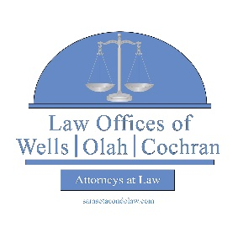
Board Certified Specialist, Condominium and Planned Development Law

“Virtually on Zoom”
Morning
November 19, 2025

“Original 4-HR"
HOA Course
8:00am - 12:00pm

It is recommended to sign into Zoom 30 minutes before the start of the course.

Please verify if you are serving on a Condominium or HOA Association board before you register, the laws are different. If unsure, please contact your association manager for clarification.

Please RSVP via sarasotacondolaw.com under “classes” or send an email to boardcertclass@gmail.com
by 12:00 noon the Monday before the event as space is limited.

Proudly Sponsored By:
“YOUR COMMUNITY PARTNERS”

